Programme Japan trip 2026
Knowledge Project: New Water Masters Japan and the Netherlands
Period: 1 September – end of October 2026
Partners: TU Delft, Stichting Blauwe Lijn, HZ University of Applied Sciences, Rotterdam University of Applied Sciences, University College Roosevelt (UCR), Watersnoodmuseum, Dutch Coastal Consortium (DCC), University of Nagoya, University of Gifu, MLIT, Richard de Boer Universal Cruise, Zeeuws Archives.
Team TU Delft: Prof. Fransje Hooimeijer, dr. Luca Iuoro, drs. Taichi Fujii, drs. Yuka Yoshida
Workgroup: Blue Line : ir. Leo van Gelder, ing. Oswald Lagendijk, drs. Yuka Yoshida, drs. Karen van Burg
Partners Japan: Prof. Dr. Demura, Dr. Ono, drs. Taichi Fuij, Richard de Boer (International Cruise)
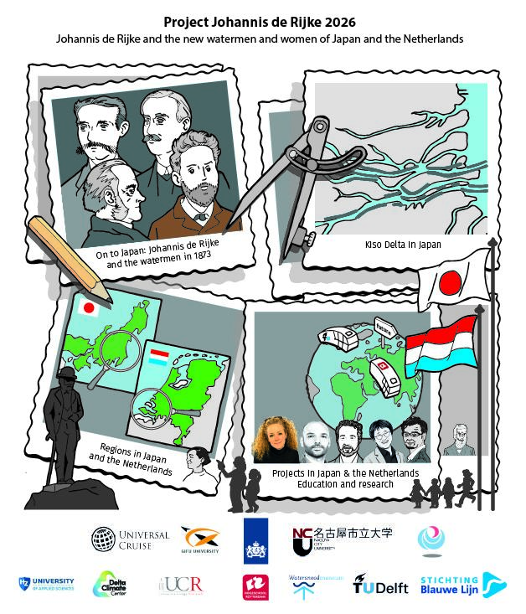





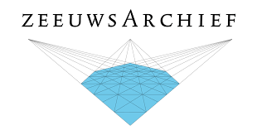

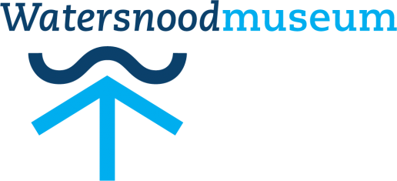

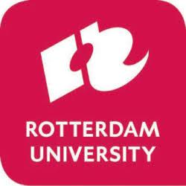






Japan

9-25 september 2026


day | hour | location | content | details
11 Sept | 9.30 | Kakamigahara City, Sangyo Bunka Center | Kick off Workshop | Intro Luca Iuorio, Karen van Burg
 |  |  |  | Greetings from Kakamigahara Municipality and dr. Ono
 |  |  |  | Lecture 1 by Taichi Fujii
 |  |  |  | Lecture 2 by Kakamigahara Municipality
 |  |  |  | Lecture 3 by Dr. Ono
 |  |  |  | Introduction to key location by Taichi Fujii
 | 12.00-13.00 |  | Lunch break | (self organized)
 | 13.00-18.00 |  | Survey (self organized) | Step 0. Individual/disciplinary: Validate the coherency of your lens and analysis during the fieldtrip. Start working on your conclusion maps*
12 Sept | 8.00 | Kanayama Station, Nagoya | Excursion | Bus boarding
 | 9.00-10.30 | Sendohira Lock
 | 11.00-12.30 | Waju Museum
 | 12.40-13.40 |  | Lunch Break | (self organized)
 | 14.00-14.20 | Mizuya House
 | 14.30-15.00 | Tatsuta Sluice
 | 16.00 | Kanayama Station, Nagoya |  | Bus unloading
13 Sept | 12.00-15.00 | Yodogawa Museum, 淀川資料館 2 Chome-2-13 Shinmachi, Hirakata, Osaka 573-1191, Japan | Visit Museum & Lunch | Explanation by the former museum director. Meeting of the book on Johannis de Rijke
 | 16.30-17.50 | Hachikenya and keihan building | Boat tour | Boattour Johannis de Rijke with Richard de Boer
14 Sept | 11.12.15 | Dutch Consulaat |  | Peer, Marieke, Karen and Richard de Boer
14 Sept | 9.30-17.30 | Nagoya City University, Faculty of Architecture and Design | Workshop | Tutored session - Whole group discussion
 |  |  |  | Step 1. Group/interdisciplinary: The first step after the lectures and field trip is to reflect as a group (with new local students) and from this develop shared values* and the group ambition*
 | 16.30-17.30 |  |  | Tutored session - Single group discussion
15 Sept | 8.15 | Kuwana Station, West Exit | Excursion | Bus boarding
 |  | Nagara River Estuary Barrage |  | Guidance by MLIT
 |  | Hanedani Sabo |  | Guidance by Dr. Kimura
 |  | Kiso Nagara Separating Levee |  | View from Bus Window View
 | 12.00 | Yatomi Station, West Exit |  | Bus unloading
 | 13.30-17.30 | Nagoya City University, Faculty of Architecture and Design | Workshop | Step 2. Individual/disciplinary: Each student develops, on the new information and experience and within the scope of the values and ambitions, their domain/disciplinary body of knowledge by means of the conclusion map and the frame of references. With the shared values and ambitions in mind each student proposes (disciplinary) design interventions that they will evaluate according to the set of shared values defined
16 Sept | 9.30-13.00 | Nagoya City University, Faculty of Architecture and Design | Workshop | Step 3. Group/interdisciplinary: The students integrate their design interventions one-on-one in several charrette rounds and eventually define the final spatial vision* and strategy*. This spatial strategy is connected and (re)contextualized to the original ambitions and translated in a clear concept* (guiding theme)
 | 13.00-14.00 |  |  | Tutored session - Single group discussion
 | 14.00-17.30 |  |  | Continue with Step 3
17 Sept | 9.30-10.30 | Nagoya City University, Faculty of Architecture and Design | Workshop | Tutored session - Whole group discussion
 | 10.30-12.30 |  |  | Step 4. Individual/disciplinary: Clearly develop disciplinary interventions and how to strategize them into the group strategy (this is an extra step for the strategy in the case it is needed)
 | 12.30-16.30 |  |  | Step 5. Group/interdisciplinary: The spatial vision is developed. The strategy is drafted in guidelines and initial spatial technical design interventions
 | 16.30-17.30 |  |  | Groups presentations - Whole group
18 Sept | 9.30-16.00 | Nagoya City University, Faculty of Architecture and Design | Workshop | Step 5. Group/interdisciplinary: The spatial vision is finalized. The strategy is worked out in guidelines and initial spatial technical design interventions presented in a project taxonomy*  Results: presentation with outcome of fieldtrip and workshop including spatial vision and strategy, guidelines, taxonomy of individual interventions (photographs, maps, drawings, sections, impressions, diagrams, schemes, tables, etc)
 | 16.00-17.30 |  |  | Tutored session - Whole and single group discussion
25 Sept | 9.00 | Kakamigahara City, Sangyo Bunka Center | Final Presentations | Intro dr. Ono, Taichi Fujii, Luca Iuorio
 | 9.10 |  |  | Presentation group 1 with Q&A
 | 9.50 |  |  | Presentation group 2 with Q&A
 | 10.30-11.00 |  |  | Break
 | 11.00-11.40 |  |  | Presentation group 3 with Q&A
 | 11.40-12.00 |  |  | Overall discussion and closing
 | 17.00-19.30 | Nagoya | Aperitivo | TBD

